**24299 Sethonde Maurice Date: 09th Mrch,2022**

**COSC 6417: LINUX Administration.**

Scripting mini project.

Q1. A scrip for creating 10 users, their password and user account expiration date.

\***Script.**

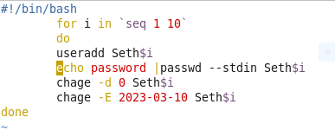

**\* Output.**

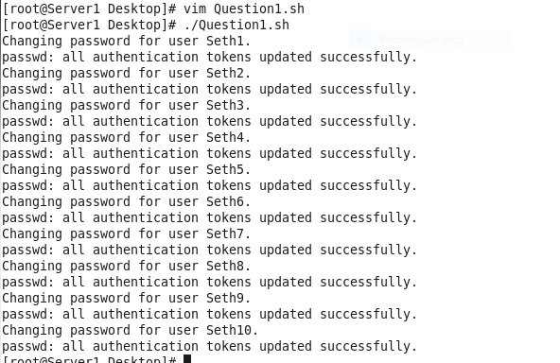

Q2. Scrip to send an email informing you of the remaining space on root partition.

**\*Mailx configuration.**

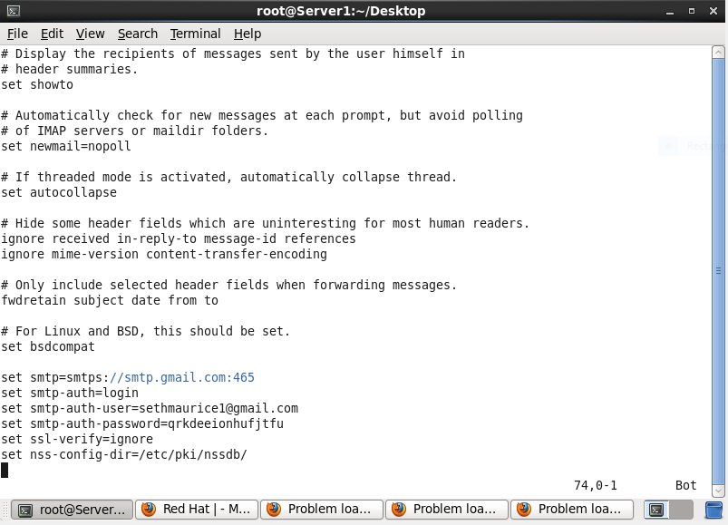

**\*Script.**

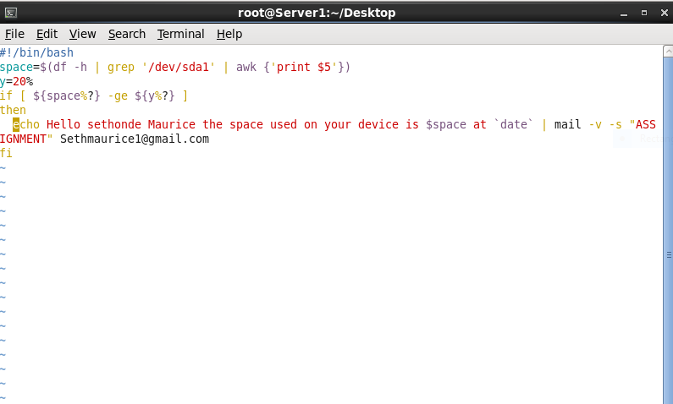

**\*Output.**

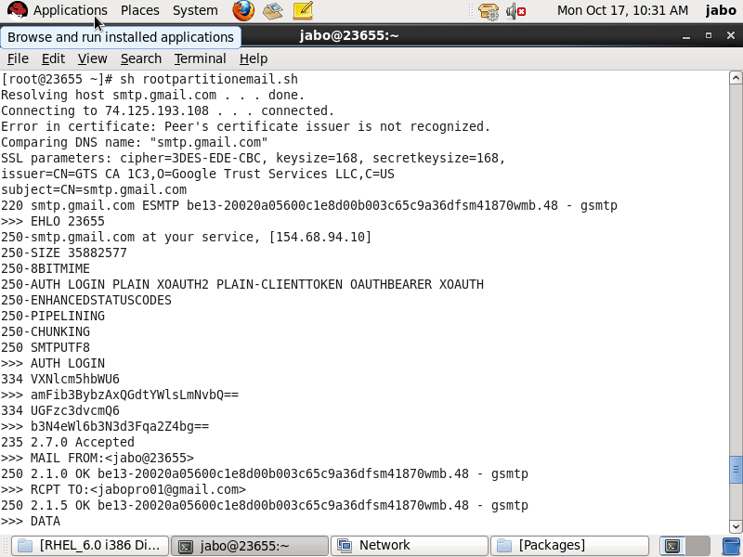

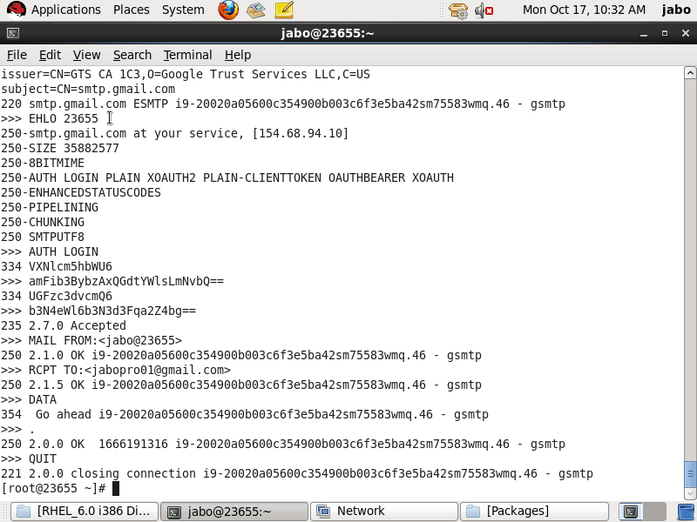

**\*My Gmail.**

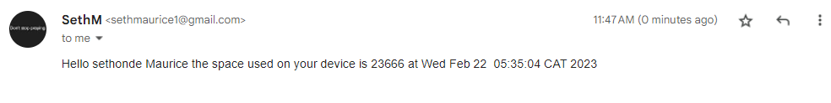

Q.3 A script for checking system resources and give highlights of programs using the most resources

**\*Script.**

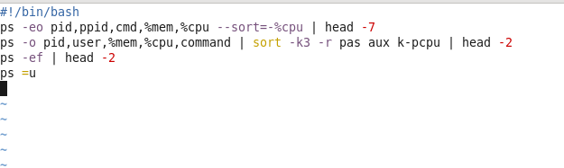

**\*Output.**

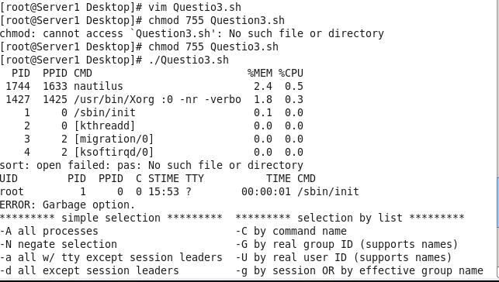

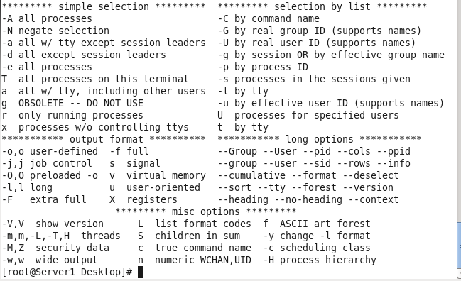

Q4. Script for daily backup for 5 users.

**\*Scrip.**

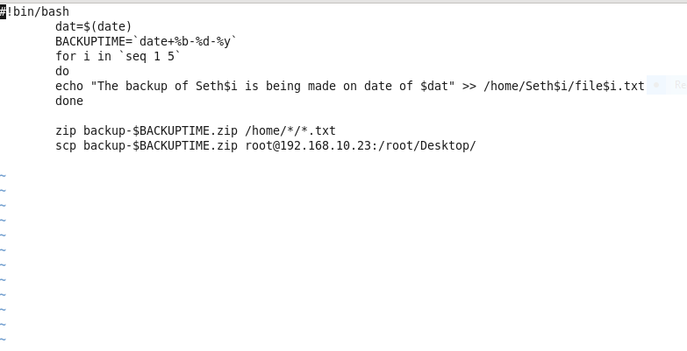

**\*Output.**

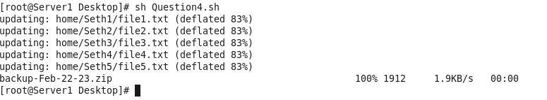

Q.5 A scrip to compare two files and sysnc them if they differ.

**\*Script.**

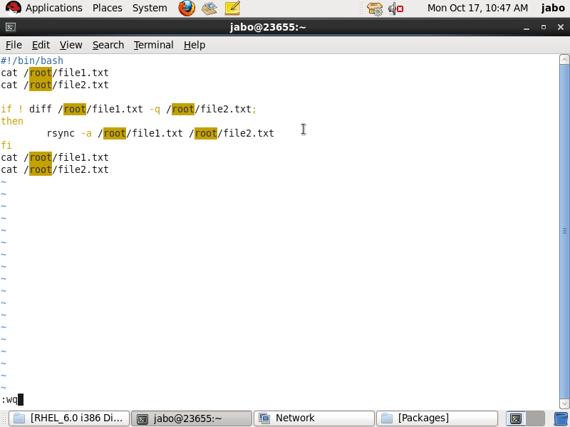

**\*Output.**

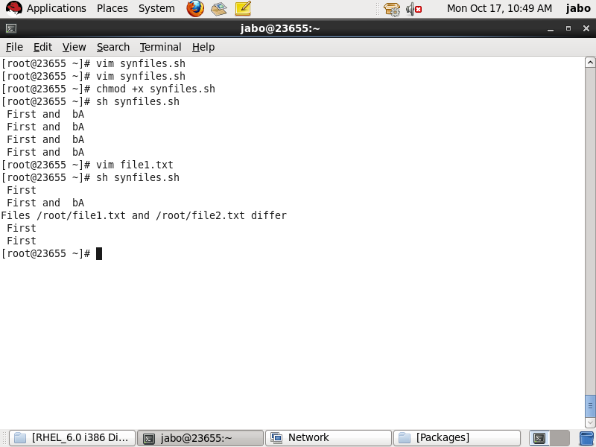

Q.6

**\*Script.**

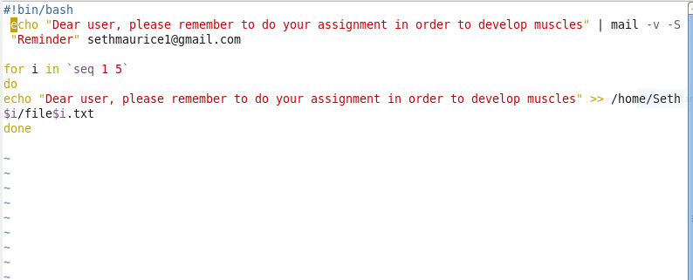

**\*Output.**